HAND PARALYSIS REHABILITATION SYSTEM

REPORT

INDEX

Sr. No. | Description | Page No.
01 | Abstract | 3
02 | Introduction | 3
03 | Problem Statement | 4
04 | Existing Rehabilitation Systems | 4
05 | Proposed Solution | 6
06 | Objectives | 6
07 | System Overview | 7
08 | Operational Phases | 8
09 | Hardware Specifications and Design | 9
10 | Software Specifications | 10
11 | Working Principle | 12
12 | Mathematical and analytical modelling | 15
13 | Data Processing | 17
14 | Expert Validation | 19
15 | Advantages | 20
16 | Applications | 20
17 | Future Scope | 21
18 | Conclusion | 22

- ABSTRACT
Hand paralysis is one of the most disabling outcomes of neurological injury, usually due to stroke, nerve damage, or spinal cord injury. It severely limits a person's basic daily activities such as grasping, lifting, and writing. Traditional rehabilitation systems target the actuation of fingers, which would only provide simple opening and closing exercises to the hand. Such systems do not help in complete recovery of the hand because they do not include the training of the wrist joint, which is very important for complete restoration of functional movement. The design of the Hand Paralysis Rehabilitation System overcomes this limitation by providing a smart, electromechanical rehabilitation device targeted at both finger and wrist rehabilitation. The three primary types of motion supported by the system are: folding/unfolding of fingers, flexion/extension of the wrist, and ulnar/radial deviation of the wrist. These exercises train multiple groups of muscles and improve coordination between fingers, wrist, and forearm, collectively contributing to better recovery. It operates in two modes: Training, machine-assisted, and Testing, patient-controlled. For progressive rehabilitation from assisted to voluntary motion, sensor data from every session are uploaded to the cloud for analysis, as explained in Section 6 - Operational Phases. The system's intelligent design ensures smooth motion control, precise data acquisition, and secure cloud storage. The proposed work will provide a low-cost, portable, and multi-axis rehabilitation platform for hand exercises, as compared to traditional rehabilitation systems that are cumbersome, expensive, or limited in the range of motion. This work bridges the gap between mechanical physiotherapy and digital health monitoring and provides active assistance along with passive assessment for complete rehabilitation of the hand. The Hand Paralysis Rehabilitation System is a huge step forward toward smarter, more accessible, and data-driven recovery for patients suffering from hand paralysis, as it is able to perform complex multi-joint motions, record motion data in real time, and provide personalized rehabilitation routines.

- INTRODUCTION
The human hand is a complex biomechanical system that enables fine, functional motion by means of the fingers, wrist, and forearm working in harmony with one another. The neuromuscular connection from the brain to these motor units becomes impaired due to the paralysis caused by stroke, peripheral nerve injury, or muscular dysfunction. Rehabilitation aims to rebuild this lost neuromuscular connection through repeated, guided motion exercises that stimulate muscle memory and re-train motor neurons.
Traditional therapy sessions, however, require constant supervision by a physiotherapist and are usually limited by time, cost, and availability. While mechanical rehabilitation devices exist, most commercially available systems have been designed to train only the grasping motions of the fingers and completely disregard the complex rotational and bending actions at the wrist. In order for complete recovery to take place, training is necessary across all relevant axes of motion, particularly flexion-extension and ulnar-radial deviation.
These gaps in rehabilitation motivated the development of the Hand Paralysis Rehabilitation System. It offers a mechatronic solution that can perform multi-axis movements with precision for accurate control, while acquiring motion data for performance evaluation. The project combines embedded systems, actuators, and cloud computing to realize both the mechanical assistance and analytical insight required for efficient and quantifiable rehabilitation.
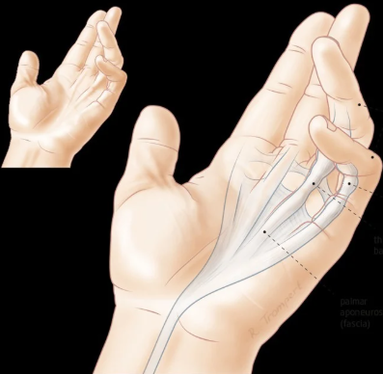

- PROBLEM STATEMENT
Patients with paralyzed hands face severe difficulties in the execution of basic activities resulting from a loss of voluntary muscle control. Most rehabilitation machines focus on finger movement-that is, the opening and closing of the hand. Training the wrist joint, which allows the hand to go through a wide range of motion, is not provided by these devices. Patients cannot perform fundamental tasks related to holding, rotating, or positioning objects without such training of wrist mobility.
Therefore, there is an evident need for a low-cost, multi-axis rehabilitation device that can assist in the movement of fingers and control of the wrist to enable more comprehensive therapy and faster recovery. This should also provide quantitative progress data to therapists for analysis and adaptive training plans.

- EXISTING REHABILITATION SYSTEMS

Before developing the proposed system, an extensive review was performed regarding the existing hand rehabilitation devices. Most commercial and research-based solutions currently available in the market were analyzed with respect to functionality, cost, motion range, and data acquisition capability. Although these systems have contributed to rehabilitation engineering, they have several technical and practical limitations which limit their accessibility and effectiveness.

4.1 Existing Products and Techniques
- MIT Manus (InMotion2) Robotic Arm – USA
- A large, clinic-based robotic arm for rehabbing strokes.
- Supports repetitive upper limb exercises with adaptive resistance.
- Limitations: High costs: >$20,000, bulky size, not widely available in smaller clinics, and it is not portable for home therapy.
- HandTutor Glove – MediTouch (Israel)
- Uses motion sensors in a fabric glove to track finger and wrist movements.
- Provides visual biofeedback for hand exercises.
- Limitations: Mainly addresses flexion–extension; no active actuation for assisted movement; requires supervision by a therapist
- SaeboGlove – Saebo Inc. (USA)
- Mechanically assisted spring glove that helps patients open and close the fingers
- Limitations: No data collection; no digital feedback; passive motion assistance only; no training of the wrist joint.
- ExoHand – Festo Robotics (Germany)
- Pneumatic exoskeleton with precise movement replication.
- Limitations: Highly complex and very expensive, not suitable for individual clinical or home-based usage; requires an air compressor and power setup externally.
- DIY/Academic Research Prototypes (Various)
- Many research projects focus on 3D-printed robotic hands controlled via servo motors or EMG signals.
- Limitations: Usually limited to single motion type, do not have integrated data tracking, and are not medically validated.

4.2 Common Limitations in Existing Devices
The analysis of current rehabilitation solutions identifies the following limitations:
- Limited Range of Motion: Most of the systems are designed for flexion and extension of fingers without considering the mobility of the wrist, such as flexion, extension, and deviation.
- Lack of Real-Time Feedback: Most of them do not provide real quantitative data on angle, speed, or repetition count to monitor improvement.
- High Cost and Complexity: These are hospital-based robotic systems that are expensive and not at all portable.
- Most of the systems do not have cloud connectivity for IoT data storage or remote monitoring.
- Dependence on Therapist Supervision: The patients cannot carry out therapies themselves and review their progress without professional guidance.
- No Adaptive or Predictive Intelligence: Current solutions do not analyse performance data to predict and personalize recovery trajectories.

- PROPOSED SOLUTION
To overcome the challenges presented above, a compact, intelligent, multi-axis rehabilitation platform has been designed called the Hand Paralysis Rehabilitation System, integrating the aspects of mechanical actuation, sensor-based feedback, and data analytics into one single device.

  - How the Proposed System Addresses Limitations:

Limitation in Existing Systems | Proposed System Improvement
Limited to finger motion | Trains both finger and wrist across three distinct modes: finger flexion/extension, wrist flexion/extension, and wrist ulnar/radial deviation.
No quantitative feedback | Integrates MPU6050 IMU sensor to measure real-time angular motion, repetitions, and range of motion (ROM).
No cloud data logging | Uses Firebase Realtime Database for remote data storage and visualization of rehabilitation progress.
High cost and bulky design | Built using low-cost, off-the-shelf components and 3D-printed parts, making it affordable and portable.
Requires constant therapist supervision | Enables home-based, self-guided therapy with automatic logging and monitoring features.
No predictive intelligence | Employs machine learning models (Linear, Polynomial, and LSTM Regression) to predict recovery trends and estimate therapy timelines.
Lack of wrist deviation training | Incorporates servo-driven ulnar–radial deviation for comprehensive wrist rehabilitation.

  - Unique Features of the Proposed System:

- Dual-Phase Operation: Training, Machine-Assisted; Testing, Patient-Controlled
- Real-Time Sensor Data Logging: Continuous IMU feedback uploaded to the cloud.
- Data-Driven Analytics: Python-based analytics to visualize and forecast recovery trends.
- Compact and Portable Design: Lightweight and battery-operated, suitable for both clinical and home use.
- Therapist Integration: It grants the ability to remotely monitor the performance without any specialized hardware.

- OBJECTIVES
The objectives of this project are:
- Design and implement a smart rehabilitation system to help restore hand motion in paralyzed patients.
- Develop a mechanism in which there are two phases: a machine-assisted Training Phase and a patient-controlled Testing Phase.
- To support three major rehabilitation modes:
- Finger folding and unfolding
- Wrist flexion and extension
- Wrist ulnar and radial deviation
- To use ESP32 as the central control unit for actuator management and cloud connectivity.
- To capture and log real-time data of motion such as angle, mode, and repetitions using Firebase Realtime Database.
- Data logging and visualization to allow remote monitoring and analysis of rehabilitation performance.

- SYSTEM OVERVIEW
The Hand Paralysis Rehabilitation System works as an integrated platform combining mechanical actuation, sensor feedback, and cloud-based data monitoring.

Key Features
- Two operational phases: Training and Testing.
- Three selectable modes targeting distinct motion patterns.
- Real-time sensor feedback using an IMU.
- Wireless data logging and remote monitoring.
- Smooth, coordinated actuation using servo and pneumatic systems.
A toggle switch selects between Training and Testing phases, while a mode button chooses the motion type. Detailed phase behavior is provided in Section 6.
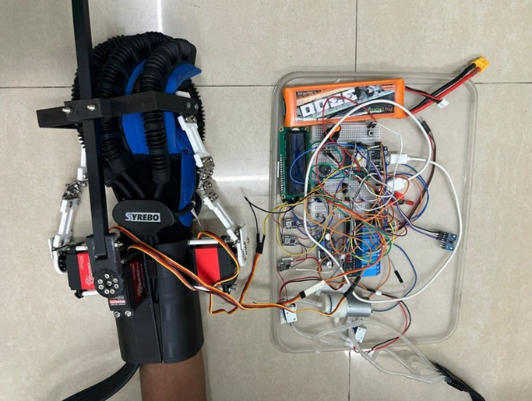

- OPERATIONAL PHASES

8.1 Training Phase
This phase provides machine-guided movement where the actuators perform controlled exercises for the patient. It allows the patient’s muscles to experience repetitive, safe, and natural motion, helping restore neuromuscular coordination.

Mode 1: Finger Folding and Unfolding
- Uses a pneumatic pump connected to an inflatable air bladder under the glove’s fingers.
- When inflated, the air bladder contracts the fingers into a fist; when deflated, it opens them.
- A solenoid valve controls airflow, synchronized with the pump.
- Helps rebuild finger flexor and extensor strength.

Mode 2: Wrist Flexion and Extension
- Uses two servo motors to control upward and downward wrist movements.
- Smoothening: Servo position values are varied smoothly without jerky motion.
- The motion trains forearm flexor and extensor muscles responsible for elevation and depression of the wrist.

Mode 3: Wrist Ulnar and Radial Deviation
- Controls lateral (side-to-side) wrist motion.
- Strengthens the wrist stabilizer muscles and enhances control for complex hand postures.
- This mode is rarely addressed by traditional rehabilitation devices.

8.2 Testing Phase
The system is switched to Testing Phase when sufficient muscle activity is regained. Here, the actuators remain off, and the patient actively moves their wrist or fingers.
- The MPU6050 IMU sensor attached near the wrist records the angular displacement.
- Data parameters such as:
  - Session ID
  - Mode number
  - Repetition count
  - Angle value
  - Timestamp
are uploaded to Firebase Realtime Database every second.
- This data allows physiotherapists to evaluate the range, accuracy, and improvement trends across multiple sessions.

- HARDWARE SPECIFICATIONS AND DESIGN
Component | Specification | Function
ESP32 Microcontroller | Dual-core 32-bit MCU with Wi-Fi & BLE | Main control unit, handles input, actuator control, and Firebase communication
MPU6050 IMU Sensor | 3-axis gyroscope + 3-axis accelerometer | Measures wrist angles and motion orientation
LCD Display | 16 x 2 characters | Used to display information
Servo Motors (x3) | 180° rotation, metal gear | Drive wrist flexion, extension, and ulnar/radial deviation
Pneumatic Pump | 7V DC mini air pump | Provides pressurized air to fold fingers
Solenoid Valve | Normally closed, 12V DC | Regulates air flow for inflation/deflation cycles
Toggle Switch | ON-OFF configuration | Switches between Training and Testing phases
Mode Button | Tactile push button | Cycles through operational modes
Potentiometer | Analog Input | Used to set the number of repetitions
Power Supply | 5V, 7V & 12V regulated | Powers ESP32, servos, and pneumatic components

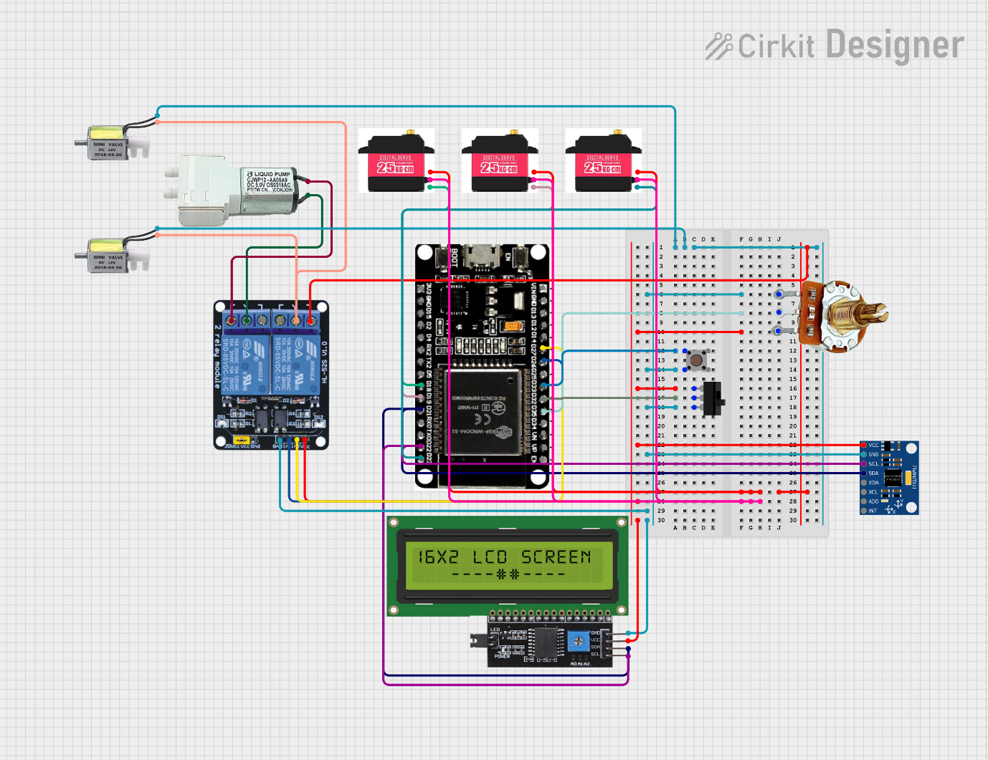

Space for pinout diagram and
graphical representation of circuit

- SOFTWARE SPECIFICATIONS
The overall software architecture of the Hand Paralysis Rehabilitation System designed herein is a hybrid framework combining embedded control (ESP32), cloud communication (Firebase), and data analytics in Python.
Each of them plays a very important role in guaranteeing synchronous actuation, reliable data transmission, and intelligent rehabilitation analysis.
The software is composed of several integrated modules developed in the Arduino IDE (for ESP32) and Python (for postprocessing, data analysis, and visualization).

10.1 Embedded Control Software (Arduino IDE + ESP32)
The ESP32 microcontroller is programmed using the Arduino IDE, uses these libraries:
- Firebase ESP32 Client for cloud communication,
- Wire.h and Adafruit_MPU6050.h for IMU data acquisition,
- Standard Servo and GPIO libraries for actuator control.
Initialization
- Enables Wi-Fi connection using SSID and password.
- Initializes the Firebase Realtime Database for data.
- Configures GPIO pins for toggle switch, mode switch button, servo control, and pneumatic pump activation.
- Calibrates the MPU6050 IMU for offset correction and stable angle readings.
- Displays system status on the LCD interface.
Control Logic
The firmware continuously monitors the hardware:
- If Training Phase:
  - Executes the pre-set servo and pneumatic sequences depending on the chosen mode.
  - Controls actuator speed via PWM to achieve smooth and natural motion.
  - Synchronizes the pump and solenoid valve operation for finger flexion and extension cycles.
- If Testing Phase:
  - Disables all actuators for safety.
  - Reads real-time IMU angle data with respect to the Y and Z axes at an interval of each second.
  - Formats the data in JSON and posts it into Firebase Realtime Database.
  - Every log entry includes session ID, mode number, angular values, and timestamp.
Firebase Data Format:
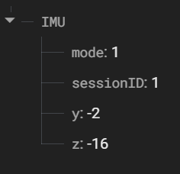
Each record shows a time-stamped sensor measurement corresponding to a patient’s wrist activity during the recovery session.
10.2 Cloud Database and Data Synchronization (Firebase)
Firebase Realtime Database serves as the central cloud platform between the ESP32 hardware and the Python-based analysis software.
- Real-time Uploads: Each data point is sent through REST API calls by the ESP32.
- Secure Storage: Firebase authenticates each data write using unique database tokens, preventing unauthorized access to happen.
- Scalable Architecture: Data is organized hierarchically by session IDs, allowing for multi-session analysis and long-term trend tracking.
- Accessibility: Data can be retrieved directly by Python scripts for either offline analytics or to build live dashboards.
Firebase now allows continuous wireless synchronization between the patient device and analytical platform, with no manual handling of data.

109.3 Data Analytics and Modeling (Python Environment)
After storing session data in Firebase, it is exported as a CSV and processed in Python.
The system performs data pre-processing, computation, and predictive modelling using Pandas, Numpy, and Scikit-learn.

Use of Libraries
- Pandas:
  - Imports CSV data into DataFrames.
  - Cleans missing or duplicate entries.
  - Groups data by session and calculates average, maximum, and minimum angles.
  - ROM is calculated per session as ROM = max(angle) - min(angle).
- numpy:
  - Handles numerical operations such as moving averages and noise filtering.
  - performs normalization and array-based mathematical computations.
  - Generates time-series arrays for regression modeling.
- scikit-learn:
  - Implements Linear Regression and Polynomial Regression models to identify recovery trends.
  - Computes various performance metrics including the R² Score, MAE, and MSE.
Supports predictive modeling for future ROM estimation based on past performance data.
The processed data is then plotted using matplotlib to generate session-wise progress graphs that include actual and predicted recovery curves.

10.4 Graphical User Interface (Tkinter GUI)
A graphical interface with Tkinter was implemented to present a more user-friendly format for the physiotherapist and patient interaction with the data analyzed.
Key Features
- CSV Import: Enables the user to select and load rehabilitation data files.
- Progress Visualization: line and bar graphs representing session progress, ROM improvements, and prediction curves
- Alerts and Message Boxes: notify users if data is missing, if an analysis is complete, or when there is an error.
- Automation Buttons: Quick access to functions like "Analyze Data", "Predict Progress", and "Export Report".
- Interactive Dashboard: Merges Python analysis with an easy-to-use interface; no need to use the command line.
This GUI converts the analytical component into a practical, non-technical interface that can be applied within clinical and academic settings.

10.5 Overall Software Workflow
- ESP32 Arduino: capture inertial measurement unit data and upload to Firebase
- Firebase: Stores and organizes real-time motion data by session.
- Python: pandas, numpy, scikit-learn - data processing, data analysis, and modeling.
- Tkinter GUI: This displays the results graphically so that a user can interpret and act on them.
This integration of embedded firmware, cloud infrastructure, and AI-driven analytics makes the Hand Paralysis Rehabilitation System a complete hardware–software ecosystem that is capable of carrying out physical therapy and also scientifically evaluating recovery.

- WORKING PRINCIPLE
The Hand Paralysis Rehabilitation System works on the principle of a properly synchronized sequence of hardware and software interactions that allow both automatic and patient-controlled exercises. The system's philosophy relies on the principle of simulating natural hand and wrist movements using actuators in the Training Phase, while capturing the patient-initiated motion data in the Testing Phase.

The working process is elaborated on through the following steps:
Step 1: Power-On and Initialization
The system switches on, and all the components included receive energy: ESP32, servo motors, pneumatic pump, solenoid valve, and MPU6050 IMU. ESP32 then performs its initialization routine, while the IMU starts the self-calibration process. Status LEDs show the ready state of the system.
Step 2: System Setup and Wi-Fi Connection
The ESP32 configures GPIO pins, initializes I²C communication with the IMU, calibrates sensors, and connects to Wi-Fi. It links to Firebase Realtime Database for automatic cloud logging once online.
Step 3: Mode Selection
A three-pin toggle switch sets the system phase:
- Training Mode: initiates guided exercises through actuators.
- Testing Mode: disables the actuators, utilizing the IMU for voluntary motion capture.
Mode Button: Cycles through three exercises:
- Finger folding/unfolding
- Wrist flexion/extension
- Wrist ulnar/radial deviation
Active mode is given through LEDs or console messages.
Step 4: Training Phase (Assisted Motion)
In Training Mode, the ESP32 drives actuators to make repetitive motions:
- Finger exercise: pneumatic bladder inflates/deflates for flexion/extension.
- Wrist flexion/extension: servos move wrist smoothly between angles.
- Wrist deviation: servos guide side-to-side motion within safe limits.
Movements are kept at consistent speed, angle, and repetition for effective rehabilitation.
Step 5: Testing Phase (Patient-Controlled Motion)
During Testing Mode, the patient moves voluntarily while the IMU captures:
- Angular position and velocity
- Motion stability (tremors or fluctuations)
Data can be recorded at timely intervals (for e.g., 1 second) for accurate trend analysis.
Step 6: Data Logging and Cloud Transmission
ESP32 packages session ID, mode, repetition number, angle, and timestamp into JSON and uploads it to Firebase. Data is stored hierarchically for easy retrieval and visualization.
Step 7: Remote Monitoring and Analysis
Motion data is accessed by therapists through Firebase dashboards in order to:
- Track performance across sessions
- Compare assisted versus voluntary motion
- Identify trends in range of motion and stability
This makes quantitative feedback available for guiding therapy adjustments and for measuring rehabilitation progress.

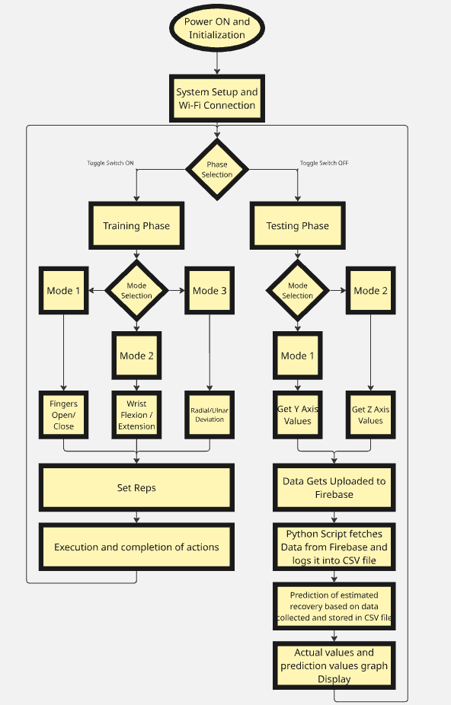

- MATHEMATICAL AND ANALYTICAL MODELLING
The mathematical and analytical framework of the developed Hand Paralysis Rehabilitation System supports kinematic calculations, control algorithms, signal processing, and predictive modeling for patient recovery analysis.

12.1 Kinematics Calculations: MPU6050 Stabilization:
The MPU6050 sensor measures continuously the acceleration and angular velocity of the wrist to track motion in real time. Employing quaternion-based sensor fusion and filters, like the Mahony algorithm, the system removes drift and noise from the signals to provide a stable wrist orientation tracking. This makes sure that the training phase precisely detects flexion, extension, and deviation of the wrist.

Quaternion rate from gyroscope:
$$\dot{q}=\frac{1}{2}q⊗ω_{raw}\text{with}ω_{raw}=[0,G_{x},G_{y},G_{z}]^{T}$$
Discrete update (Euler):
$$q_{t}=q_{t-1}+\dot{q} Δt\text{then normalize }q_{t}$$
Accelerometer-based correction (Mahony-style):
$$e=g_{meas}×g_{est} \\ ω_{err}=K_{P}e+K_{I}∫e dt$$

Corrected angular rate applied in quaternion update:
$$ω=ω_{raw}+ω_{err}$$
This mixture of gyroscope and accelerometer data provides smooth and drift-free wrist tracking throughout the exercise cycle.

12.2 Inverse Kinematics for Servo Positioning:
The system makes use of IK for the control of servo motors in the replication of movements of the wrist. Using a two-link planar arm model, mathematical equations of IK compute the servo angles θ_1and θ_2for any given position of the wrist.
Forward kinematics (end-effector at (x, y)):
$$x=L_{1}cos⁡θ_{1}+L_{2}cos⁡(θ_{1}+θ_{2}) \\ y=L_{1}sin⁡θ_{1}+L_{2}sin⁡(θ_{1}+θ_{2})$$
Solving for joint angles:
$$cos⁡θ_{2}=\frac{x^{2}+y^{2}-L_{1}^{2}-L_{2}^{2}}{2L_{1}L_{2}} \\ θ_{2}=\text{atan2}(±\sqrt{1-{cos⁡}^{2}θ_{2}},cos⁡θ_{2}) \\ θ_{1}=\text{atan2}(y,x)-\text{atan2}(L_{2}sin⁡θ_{2},L_{1}+L_{2}cos⁡θ_{2})$$
This ensures smooth, human-like wrist motion and coordinated servo positioning during rehabilitation exercises.
12.3 Power & Motor Control Expansion
This control subsystem activates servo motors and pneumatic actuators for the rehabilitation of the finger and wrist. The power circuit is regulated, which provides constant torque; the ESP32 times all actuators with precision.
Electrical power and torque:
$$P=V⋅I,τ=K_{t}I$$
DC motor speed approximation (neglecting dynamics):
$$ω≈K_{v}(V_{applied}-IR)$$
PWM duty-to-voltage mapping:
$$V_{applied}=D⋅V_{supply}\text{(where 0 ≤ D ≤ 1 is PWM duty)}$$
Servo position control (PID):
$$u(t)=K_{P}e(t)+K_{I}∫e(t) dt+K_{D}\frac{de(t)}{dt} \\ e(t)=θ_{target}-θ_{meas}$$
This guarantees smooth, stable servo movement, with very minimal overshoot, providing accurate position control.

12.4 Advanced Signal Analysis for Progression
Digital bandpass filters remove high-frequency noise from raw IMU and servo feedback data to ensure clean motion profiles for analysis.

Bandpass filter transfer function (Butterworth example):
$$H(s)=\frac{ω_{0}^{2}}{s^{2}+\sqrt{2}ω_{0}s+ω_{0}^{2}}$$
Discrete form (using bilinear transform):
$$y[n]=b_{0}x[n]+b_{1}x[n-1]+b_{2}x[n-2]-a_{1}y[n-1]-a_{2}y[n-2]$$
Feature extraction for rehabilitation analysis:
$$ROM_{session}=max⁡(θ(t))-min⁡(θ(t)) \\ smooth ROM=moving_avg(ROM,w)$$
This filtering and feature extraction enhance the accuracy of detecting progress trends across multiple rehabilitation sessions.

12.5 Time-Series Predictive Modeling
Machine learning algorithms such as Linear Regression, Polynomial Regression, and LSTM neural networks implemented in Python are used to predict the progress of recovery.

Linear regression model:
$${\hat{y}}_{t}=β_{0}+β_{1}t$$
Polynomial regression (degree d):
$${\hat{y}}_{t}=β_{0}+β_{1}t+β_{2}t^{2}+⋯+β_{d}t^{d}$$
LSTM cell operations (per time step t):
$$f_{t}=σ(W_{f}x_{t}+U_{f}h_{t-1}+b_{f}) \\ i_{t}=σ(W_{i}x_{t}+U_{i}h_{t-1}+b_{i}) \\ {\tilde{c}}_{t}=tanh⁡(W_{c}x_{t}+U_{c}h_{t-1}+b_{c}) \\ c_{t}=f_{t}⊙c_{t-1}+i_{t}⊙{\tilde{c}}_{t} \\ o_{t}=σ(W_{o}x_{t}+U_{o}h_{t-1}+b_{o}) \\ h_{t}=o_{t}⊙tanh⁡(c_{t}) \\ {\hat{y}}_{t+1}=Dense(h_{t})$$
These models process time-series data of wrist motion from Firebase to predict recovery rates, identify trends of improvement, and estimate the expected timeline for recovery.

- DATA PROCESSING
This proposed system is an affordable, portable, data-driven solution for hand and wrist rehabilitation, offering considerable improvements over traditional therapeutic methods and their existing commercial rehabilitation devices.
The combination of real-time sensor data acquisition and intelligent cloud storage provides an advanced data analytics system that permits the quantitative evaluation of patient progress. This allows for measurable feedback to therapists, as well as the possibility of adaptive therapy adjustments based on recovery trends over time. The following subsections will explain how such data collection, processing, and analysis provide predictive rehabilitation outcomes.

13.1 Data Collection Process:
During the Testing Phase, the MPU6050 inertial measurement unit (IMU) continuously measures wrist motion across two axes — X: flexion–extension and Y: ulnar–radial deviation - from which ROM, a major metric for assessing rehabilitation progress, is calculated.
Each rehabilitation session is uniquely identified and logged through the ESP32 microcontroller, transmitting all the relevant parameters to the Firebase Realtime Database in real time. The following are key data parameters:
- Session ID: Unique identifier for each training or testing session.
- Mode Number: Indicates the type of motion performed (finger, flexion–extension, or deviation).
- Timestamp: Time of each recorded data point for session-wise tracking.
- Angular Motion Data: Captured wrist rotation angle in degrees over time.
- ROM Value: Computed as the difference between maximum and minimum angular displacement in each cycle.
Preprocessing includes calibration, the rejection of outliers, and moving-average filtering in order to ensure the accuracy and consistency of the data. This removes measurement noise due to sensor drift, vibration, or involuntary tremors. This refined, quality dataset forms the backbone of predictive modeling and recovery analytics.
Real-time cloud integration through Firebase also allows for seamless remote monitoring. This enables physiotherapists or researchers to view patient performance trends on live dashboards, assuring data continuity across sessions and therapy environments-home or clinic.

13.2 Data Analysis Process:
Once the filtered motion data is stored in Firebase, it is exported for analysis with Python-based tools such as pandas, NumPy, matplotlib, and scikit-learn. The main objective of the analysis will be to find the recovery patterns, quantify the improvement, and forecast future rehabilitation results using both statistical and machine learning models.

1. Regression-Based Trend Analysis:
Linear and Polynomial Regression models are implemented on session-wise ROM data to identify improvement trends over time.
- Linear Regression determines the overall rate of recovery through a straight-line fit.
- Polynomial Regression better reflects non-linear recovery curves, which more accurately represent real-world patient progress, usually accelerating once there is initial muscle reactivation.
These regression models provide fitted curves representing the relationship between session count and motion capability, thereby allowing easy visualization of rehabilitation performance.

2. Time-Series Predictive Modelling (LSTM):
Temporal dependencies are modeled in the data using Long Short-Term Memory neural networks. An LSTM network is able to remember the historical trend and estimate future movement potential based on past performance.
This enables the system to estimate:
- Expected timeline of recovery.
- rates of improvement per session,
- Predicted range of motion for future therapy cycles.

3. Visualization and Performance Metrics:
The processed data is plotted as:
- Actual vs. Predicted ROM graphs: showing how well the models fit the observed recovery data.
- Charts that map session progress, showing incremental improvements over several training sessions.
Metrics such as the Mean Squared Error and Coefficient of Determination (R²) can be calculated in order to evaluate the model's reliability. Lower MSE and higher values of R² indicate strong model accuracy and effective data correlation with patient performance.

4. Clinical Insight Generation:
The results are interpreted to give quantitative insights to physiotherapists. Based on the progress rate observed and predicted outcomes, the therapist can:
- Adjust training duration or motion difficulty,
- Reduce or increase machine assistance levels,
- Determine plateaus in recovery for intervention.
Through this process, raw motion data are converted into actionable intelligence, serving as a bridge between engineering data and medical decision-making. This then leads to an analytical framework for personalized therapy planning that ensures efficient evidence-based patient rehabilitation.
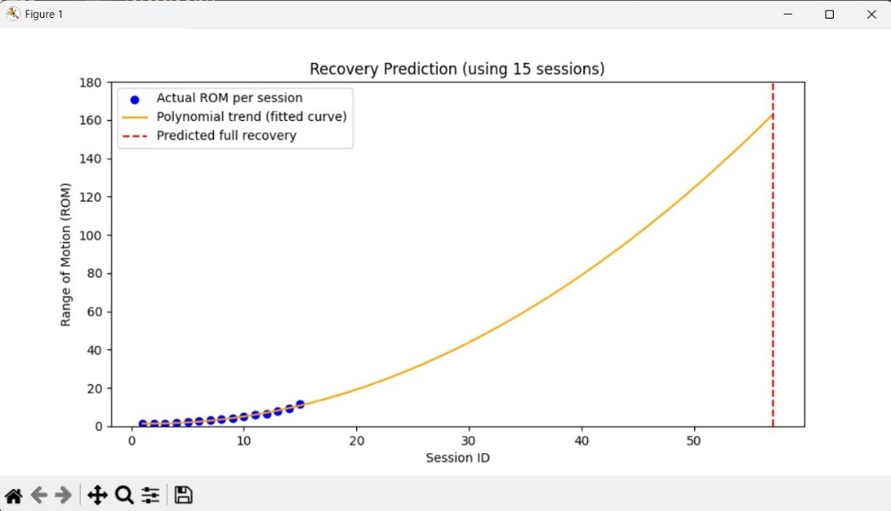

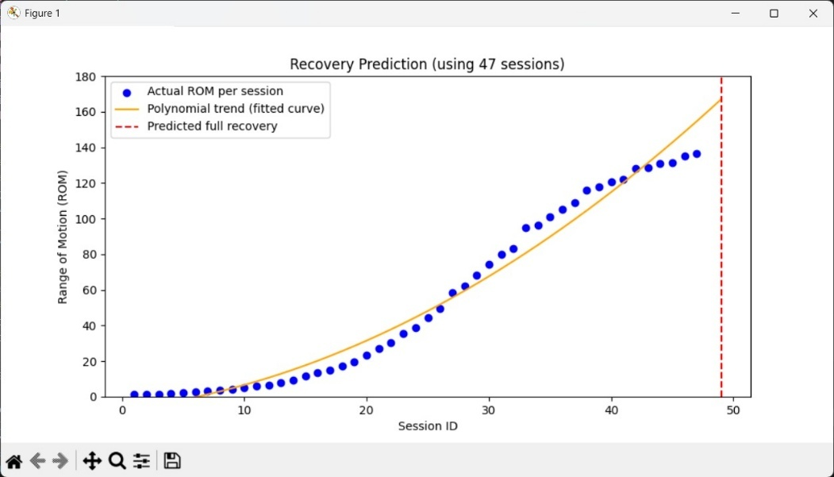

- EXPERT VALIDATION
The system was reviewed and validated under supervised testing by medical and rehabilitation experts. Their key feedback included:
- Bionics Innovations (Certified Manufacturer):
Emphasized the incorporation of wrist twist motion to simulate natural hand behavior.
- Dr. Sahab Thaver (Physiotherapist, Nanavati Hospital):
Suggested using the device for repetition-based therapy for sustained recovery.
- Dr. Mansi Thakkar (Physiotherapist, Private Practitioner):
It was recommended to gradually reduce the assistance in order to increase the patient's engagement and muscle strength.
This checking of the system by experts guarantees its effectiveness, therapeutic efficacy, and user-friendliness.

- ADVANTAGES
The proposed system offers a cost-effective, portable, and data-driven solution for hand and wrist rehabilitation, improving on traditional techniques and commercial devices.
- Multi-Axis Rehabilitation
  - Supports both finger and wrist motion for holistic recovery.
  - Pneumatic module enables finger flexion/extension; servo-controlled assembly allows wrist flexion-extension and deviation.
  - Targets multiple muscle groups simultaneously, mimicking physiotherapist-guided exercises.
- Low-Cost, Portable Design
  - Built with affordable, off-the-shelf components and 3D-printed parts.
  - Lightweight, compact, and battery-powered, suitable for home or remote use.
- Wireless Monitoring & Cloud Connectivity
  - ESP32 uploads session data to Firebase in real time.
  - Enables remote progress tracking via web or mobile dashboards.
  - Reduces wiring, enhancing patient comfort and safety.
- Quantitative Progress Tracking
  - IMU sensor records real-time angles, speed, and movement smoothness.
  - Enables data-driven therapy adjustments and long-term performance analysis.
- Safe & Controlled Operation
  - Smooth motion profiles regulated pneumatic pressure, mechanical range limiters, and emergency stop ensure patient safety.
- Dual-Phase Adaptability
  - Training Phase: Assisted movements for early-stage recovery.
  - Testing Phase: Active patient-driven movements for quantitative assessment.
  - Supports complete rehabilitation from assisted to independent motion.

- APPLICATIONS

The Hand Paralysis Rehabilitation System has a broad range of applications in the fields of medical rehabilitation, physiotherapy, and biomedical research. The flexible design makes it possible for it to be used across different recovery stages and environments, from clinical setups to home-based therapy systems.

1. Post-Stroke Hand and Wrist Rehabilitation

One of the main applications of this system is in rehabilitation, particularly for those stroke patients who have partial or complete paralysis of their hand and wrist. The device helps restore neuromuscular coordination by guiding the wrist and fingers through repetitive motion cycles. Such repetitive, controlled exercises are known to improve neural plasticity, the ability of the brain to rewire motor pathways, thereby accelerating recovery of voluntary control.

2. Recovery After Nerve Injury or Orthopedic Surgery

Stiffness and a lack of mobility in either the wrist or fingers are common side effects in patients recuperating from peripheral nerve injuries, fractures, or tendon repairs. This rehabilitation system provides these patients with a safe and progressive joint mobilization along with strength retraining without requiring continuous supervision by a therapist. It ensures that the healing tissues are moved within safe limits to forestall muscle atrophy and maintain joint flexibility while recovering.

3. Physiotherapy Clinics and Rehabilitation Centers

This system can be applied to professional physiotherapeutic clinics and rehabilitation centers as an assistant training tool. The movement type and speed for each individual patient can be set up by therapists, while the cloud-based data logging enables remote monitoring or the long-term storing of patient data. Its affordability and compact size make it suitable for multi-patient use or integration into an existing physiotherapy program without major infrastructure changes.

4. At-Home Therapy for Paralyzed or Mobility-Impaired Patients

The device can easily be used for home-based rehabilitation because it is lightweight, low-cost, and Wi-Fi-enabled. Those who cannot visit the clinics frequently can carry out daily exercises independently while therapists review their data remotely through the Firebase database. This will vastly improve access to therapy and continuity of treatment, which is particularly important for the long-term outcome of recovery.

5. Research in Robotic Rehabilitation and Human–Machine Interaction
Beyond clinical use, the project is a research platform for studies in robotic rehabilitation, biomechanics, and human–machine interaction. The system provides a platform from which to analyze motion patterns, evaluate control algorithms, or explore adaptive feedback mechanisms in assistive robotics. Its modular, open-ended design allows easy customization for testing new actuators, sensors, or AI-driven control methods in future rehabilitation technologies.

- FUTURE SCOPE
In the future, the Hand Paralysis Rehabilitation System could be further improved by incorporating advanced technologies and more intelligent control methods.
Improvements in this system can be made on various dimensions, thereby enhancing its efficiency, adaptability, and clinical usefulness.

1. Integration of Mobile App Dashboard for Real-Time Visualization
One can also design a dedicated mobile or web application for therapists and patients to track real-time rehabilitation data, like joint angles, repetition count, and session duration. An intuitive dashboard could be implemented to visually display live motion graphs, session summaries, and progress analytics in an easily understandable form. This would drive better engagement for patients during home therapy sessions and allow therapists to track the patient's progress without directly accessing raw Firebase data.

2. Use of Machine Learning Algorithms to Analyze Improvement Trends
This can be furthered by introducing machine learning on the volumes of motion data from multiple therapy sessions. Training on parameters such as angle range, speed, and smoothness, the system automatically predicts recovery trends, detects abnormal motion patterns, and suggests exercise adjustments. Gradually, this may allow the system to personalize the therapy routine regarding the patient's improvement rate, thus establishing a data-driven adaptive rehabilitation model.

3. Implementation of Adaptive Motion Profiles Based on Patient Progress
Currently, the movement patterns and speeds are preprogrammed and are manually selected by the therapist or user. Future versions can be implemented with adaptive motion profiles that automatically adjust movement speed, range, or resistance based on measured strength and progress of the patient. For example, while the patient is regaining control, the system will gradually reduce assistance to promote active participation and muscle re-education. The device would be more intelligent and responsive to an individual's rehabilitation needs.

4. Incorporation of Voice or Gesture Control for Enhanced Accessibility
Inclusion of voice or gesture control to enhance accessibility. This system can further be enhanced for ease of use by patients with limited hand mobility through voice commands or gesture-based controls. For example, using simple voice recognition modules or camera-based gesture detection, patients could start, stop, or change modes without pressing physical buttons. Such adaptations make the device more accessible to individuals with severe paralysis or limited mobility, enhancing overall user independence and comfort.

- CONCLUSION
The Hand Paralysis Rehabilitation System successfully combines hardware with control electronics and cloud-based data logging on one rehabilitation platform. Unlike typical systems that address only finger motion, the device offers multi-axis training for both fingers and wrist movement.
It allows the gradual transitioning of the patient from active-assistive motion to voluntary control by including Training and Testing phases. The integration of the IMU sensor along with Firebase cloud makes certain that data from each session is logged and can enable personalized progress tracking and data-driven medical assessment.
This project demonstrates how embedded systems, mechanical actuation, and IoT technologies can be integrated to create an affordable, intelligent rehabilitation solution that empowers patients to regain independence and functionality.
*********************

